KINDERGARTEN CLASS FOURTH GRADING DAILY PLANS
WEEK 37: _________________
Monday | Tuesday | Wednesday
MEETING TIME 1: | MEETING TIME 1: | MEETING TIME 1:
Message: People must keep their rivers, lakes and seas clean by not throwing trash into it . | Message: People must care for plants in the community. | Message: People must care for the animals in the community.
Questions: How can we keep bodies of water clean? Why do we need to keep bodies of water clean? | Questions: How can we take care of the plants in the community? | Questions: How can we take care of the animals in our community?
WORK PERIOD 1 | WORK PERIOD 1 | WORK PERIOD 1
Teacher-Supervised:  What will happen if people keep throwing trash into our bodies of water?  Fish It Out | Teacher-Supervised: Nature Walk | Teacher-Supervised:  Pet Care Poster  Plant Helper Activity
Independent:  Word Sorts  Pick a Syllable  Talk a Drawing  Word Tic-tac-Toe  Writer’s Workshop | Independent:  - Word Sorts  - Pick a Syllable  - Word Tic-tac-toe  - Make a Match  - Plant Parts Memory Game | Independent:  - Jigsaw Sentences  - Plant Part Memory Game  - Pencil Decoration Flower Craft  - Animal Bingo  - Where’s the sound?
MEETING TIME 2:  Question: What kinds of bodies of water have you seen or been to ?  (lake, river, sea, etc.) | Introduce the song : “ I am Little Seed “  Invite the group who went on Nature Walk to share their experiences while going around the school, looking for plants/trees. | MEETING TIME 2:  Read and discuss the poem  “What makes a garden grow, grow, grow…? “
Supervised Recess | Supervised Recess | Supervised Recess
STORY: The Fish Who Wish He Could Fly | STORY: Halinang Mamasyal sa Hardin (PEHT p.110 | STORY: The Tiger in the Cage
WORK PERIOD 2: | WORK PERIOD 2: | WORK PERIOD 2:
Teacher-Supervised: multiplication stories(  counting 2-3 groups of the same quantity) | Teacher-Supervised: multiplication stories  (counting __ groups of 2 and 3) | Teacher-Supervised: Frogs & toads
Independent:  - Block Play  - Egg-o  - Subtraction Cards  - Tapatan  - Don’t Rock the Boat | Independent:  - Block Play  - Egg-o  - Subtraction Cards  - Tapatan  - Don’t Rock the Boat | Independent:  - Block Play  - Tens Concentration  - Go 10/ Draw 10/ Find 10  - Make 10  - Busy Bee
INDOOR/OUTDOOR ACTIVITY: Family Scavenger Hunt | INDOOR/OUTDOOR ACTIVITY: Names HOpscotch | INDOOR/OUTDOOR ACTIVITY: Planting Rice Relay
MEETING TIME 3: Dismissal Routine | MEETING TIME 3: Dismissal Routine | MEETING TIME 3: Dismissal Routine

THURSDAY | FRIDAY | NOTES
MEETING TIME 1: | MEETING TIME 1:
Message: People in the community should plant more trees. | Message: People in the community should stop other people from cutting down trees.
Questions: Do you think we should plant more trees? Why? | Questions: How can we stop people from cutting trees in the community? What will happen if trees are cut down?
WORK PERIOD 1 | WORK PERIOD 1
Teacher-Supervised:  Poster: Caring for Our Community  A Letter to the Mayor from the Kindergarten Class | Teacher-Supervised:  Big Book: Caring for Our Community  Go Hunting Go
Independent:  - Pick a Syllable  - Make a Match  - Mystery Words  - WS: Picture-Word Match ( Animals)  - Sand Play | Independent:  - Literature-based: Story Sequence Chart (The Little Red Hen)  - Lliterature-based: Story Map  - WS: Which does not belong? (animal habitat)  - Sand Play  - Writer’s Workshop
MEETING TIME 2:  Read the letter to the Mayor to the class  Show poster on Caring for the Community. Talk about how their family can help keep the community clean  Oral Oddity Task (Which does not belong?) –Final Sounds | MEETING TIME 2:  Songs: The Gardener Plants the Seeds  Itsy Bitsy Spider  Oral Oddity Task (Which does not belong?) –Final Sounds
Supervised Recess | Supervised Recess
STORY: The Little Red Hen | STORY: The Little Tree That Longed for Other Trees
WORK PERIOD 2: | WORK PERIOD 2:
Teacher-Supervised: Frogs & toads in a line | Teacher-Supervised: Surprising Symmetry
Independent:  - Block Play  - Tens Concentration  - Go 10/ Draw 10/ Find 10  - Make 10  - Busy Bee | Independent:  - Block Play  - Pattern Blocks  - Tangram Puzzles  - Balloons  - Train Ride
INDOOR/OUTDOOR ACTIVITY: Ten and Out | INDOOR/OUTDOOR ACTIVITY: Animal Relay
MEETING TIME 3: Dismissal Routine | MEETING TIME 3: Dismissal Routine

APPENDIX Week 37

SMALL GROUP ACTIVITIES

- THEME RELATED ACTIVITIES

Fish It Out!
Objective: to develop gross/fine motor skills
Materials: “litter” – plastic bags, an old shoe or slipper, other junk/trash items, Fishing rods (sticks with bent-back paperclips as hooks
Number of players/participants: 3-4
Procedure:
- Scatter the “litter” on the floor or on a big shallow basin. Give each child one fishing rod.
- Children will play a modified version of a fishing game. Instead of fishing for fishes, they will attempt to remove various items that “litter” a body of water (ex. plastic bags, an old shoe, and other junk items/trash).The activity is finished when the body of water is “clean” and no more garbage is found.

Plant Helper Activity
Objective: to demonstrate care for the environment/ their surroundings by picking up trash and watering plants; to identify areas in the school that are often littered and need cleaning and maintenance.
Materials: plastic trash bags, pails of water and small empty plastic cups with the ends punctured (to serve as the watering can)
Number of players/participants: 4-5
Procedure:
Children will go around the school and water the plants and trees within the school grounds. They will also pick up any litter they find along the way (ex. candy wrappers, small bits of paper, etc.)

Pet Care Poster
Objective: to describe various ways different pets can be taken cared of
Materials: poster paper, pencils, coloring materials
Number of players/participants: 4-5
Procedure:
Children will identify animals that are commonly found in the community (either owned as household pets or found in public places). As a group, they will discuss different ways of taking care of these animals and/or keeping them safe and make a poster on Pet Care for animals that are commonly found in their community. At the end of the day, children can bring home the poster they made so they can post it in their homes or other places in the community.

Poster: Caring for the Community

Materials: glue, construction paper, scissors, pencil, crayons, manila paper
Number of Participants: 6-8 children
Procedure: Have children think of ways people can take care of their community. Let them draw these on pre-cut construction paper. Have them glue this on manila paper. Let them label their work.

Big Book : Caring for our Community

Materials. Manila paper, construction paper, bond paper, scissors, crayons, markers
Number of participants: 6-8 children
Procedure: Invite children to think about ways people can take care of their community. Have them illustrate these on each page of the big book.

Pencil Decoration Flower Craft
Objective: to develop fine motor skills; follow directions/art activity
Materials: Scissors ,Tape ,pencil ,markers (optional)
Number of players/participant: 3-4 players or it can also be played by just one child
Procedure:
- Cut a long strip of paper (about the size of half a piece of notebook paper).
- Fold the paper in half, and then in half again.
- Cut a series of slits in the folded paper - do not cut all the way through to the ends, leave a small section uncut.
- Unfold the paper. Tape one end of the uncut portion to the eraser end of the pencil.
- Roll the paper around the pencil. When you've rolled it all, tape the end of the paper to the pencil.
- Gently push the pieces of paper away from the eraser, making it look like a flower.
- You now have a cute, decorated pencil.

Nature Walk
Objective: to identify and name different kinds of foliage that grows within the school grounds
Materials: for tour: ¼ pieces of paper for labelling, pencils and tape
for follow up activity – manila paper, pencils and coloring materials
Number of players/participants: 5-6
Procedure:
- Go on a guided tour of the school grounds – children will identify what kinds of plants and trees grow in their school, sticking labels each plant/tree as they go along.
- Follow-up activity: when they return to the classroom, they will make a school map that shows the different kinds of plants and trees and where these plants and trees are located.

A Letter to the Mayor
Objectives: to organize ideas, to compose a letter, to establish cause and effect relationships
Materials: letter paper, mailing envelope, pencils
Number of players/participants: 4-5
Procedure:
- Explain to the children that they are going to write to the mayor (or could be barangay head, or even school principal) regarding environmental concerns in and around the community. Encourage them to brainstorm their ideas first, sharing observations about trash/littering problems, pollution, cutting down of trees/plants, etc as well as their proposed solutions.
- After the short brainstorming session,let them compose their letter to the mayor.. Aside from highlighting the environmental problems in the community, encourage them to also write about what may happen if these problems will persist (ex. Compromised health of residents, flooding, less shade, etc.)
- Children may also include drawings/illustrations to accompany their letter. After writing the letter, read this to the class. If there is nothing else they want to add, put the letter in an envelope. The following day, tag along a few class representative to take this letter to the barangay hall.

OTHER MATH ACTIVITIES

Multiplication Stories
Objective: to explore the concept of multiplication by counting groups of the same quantity
Materials: counting boards and counters
Procedure:
Depending on the counting boards and counters you will use for a particular work period, tell the children stories, and have them use the counters to represent the objects, animals, people in the story. The counting boards will help children visualize the number of groups, while the counters represent the number of objects in each group.

Frogs and Toads
Objectives: to sort objects into sets
Players: pairs or small group
Materials: frogs drawn on green construction paper and toads drawn on brown construction paper
Small box or sack
Procedure:
- Have students sit in a circle with the teacher.
- Keep one frog and one toad. Pass the sack around and have each child take one piece.
- Place one frog in the center of the circle and a toad in another spot in the center. Point to the frog and say, “This is a frog. If you have a frog put it here.” Then point to the toad and say, “This is a toad. If you have a toad put it here.”

Frogs and Toads in a Line
Objectives: to identify the ordinal positions
Players: pairs or small group
Materials: frogs drawn on green construction paper and toads drawn on brown construction paper
(see reproducible)
small box or sack
Procedure:
- Have students sit in a line facing teacher.
- Begin with only 3 frogs or toads. Use those with distinctive differences so students will have no difficulty describing them. (ex. Small hopping frog, large sitting toad)
- Ask, “which one is first in line? Which is last?”
- Remove the last one and ask, “Which one is last now?”
- Place several frogs and toads in a row. Have students repeat after you as you point to the frogs and toads and count, “first, second, third, etc.”
- Ask questions such as: Which frog is second? Is the small bumpy toad first or last? Which frog is in third place – the little one or big one?

Surprising Symmetry
Objective: to explore the concept of symmetry
Materials: scratch paper, paint, popsicle sticks
Procedure:
- Fold a piece of paper in half.
- Open it up and put fairly runny paint on the half near the fold.
- Fold the clean half over and press hard all over before opening it up again.
Suggestion: Dip a piece of yarn in paint. Place the yarn between the folds. Pull the yarn then open the paper.

Egg-O
Objective: to practice adding and subtracting skills
Players: 2-4 players
Materials: 2 small counters
egg carton with numbers written in this way:

3
4
1
5
0
2

0
2
4
3
1
5

Procedure:
- Egg-o is played in rounds, with play rotating clockwise. During each round, each player takes a turn putting the two counters in the egg carton, closing it, shaking it, and then opening the carton to see where the counters landed.
- In the addition game a player’s score is the sum of the two numbers that the counters landed in. During the subtracting or multiplication game, the players find either the difference or product of the numbers.
- The player with the highest score wins one point for the round. The player to acquire 5 points first wins.

Make Ten
Objective: to explore different combinations that make 10
Materials: paper, pen, one playing die, game board at least twenty counters
Procedure:
1. Give each player a playing board.

1 2 3 4 5 6 7 8 9 10 | 1 2 3 4 5 6 7 8 9 10

2. Players take turns throwing the die.
3. Player gets as many counters as the number that comes out.
4. Throughout the game the teacher asks questions such as " How many more do you need to reach ten? "
5. Player who reaches ten first wins.

Variation: Players fill up playing board with ten counters. Counters are removed from board
as player throws the die.

Subtraction Cards
Objective: to subtract quantities
Materials: subtraction cards, counters
Procedure:
1. Teacher reads the total on the card, for example 7.
2. Children get 7 counters.
3. Teacher says "take away three" while lifting the right hand flip.
4. Children take away 3 counters, count remaining counters and say "Four"
5. Teacher shows the group the four remaining dots on the subtraction card.

Find 10
Objective: to explore different combinations that make 10
Materials: 6 sets of numeral cards (1- 9)
Procedure:
1. All cards are dealt. Last card is turned face up. Each player keeps the cards dealt to him in a stack, face-down, without looking at them.
2. By turns, players turn over the top card of his stack. If this card can be used with one on the table to make a total of 10, the player can take it and keep the pair. If there are no cards that can be used, he has to discard his card in the middle of the table, face up.
3. The player who collects the most number of pairs wins.

Draw 10
Objective: to explore different combinations that make 10
Materials: 6 sets of numeral cards (1- 9)
Procedure:
1. One card is drawn from the deck and is set aside throughout the game, so that there will be an odd card without a mate at the end of the game. All the other cards are dealt.
2. Each player goes through the cards received trying to find pairs that make 10. All the pairs thus made are discarded in the middle of the table.
3. The players then take turns, each holding her cards like a fan and letting the person to her left draw one of them without looking at them. If the person who draws the card can use it to make 10 with one of the cards in her hand, she discards the pair in the middle of the table. If she cannot use it, she has to keep it. She then holds all her cards like a fan so that the person to her left can draw one of them by chance.
4. Play continues until one person is left holding the odd card and loses the game.

Tens Concentration
Objective: to explore different combinations that make 10
Materials: 6 sets of numeral cards (1- 9)
Procedure:
1. Sixteen cards are placed in the middle of the table, face down, in a 4 x 4 arrangement. The remaining cards are placed faced-down in a stack.
2. The players take turns turning over two cards, trying to turn a pair that totals 10. If a pair can be made, the player keeps it and continues to play as long as he is successful. If he is not successful, he returns the two cards to their original face-down positions and replaces any cards he took with new ones from the deck.
3. With 16 face-down cards on the table, the turn passes to the next player to the left..
4. The person who collects the greatest number of pairs is the winner.

Variation: This game can be varied by increasing the number of cards placed on the table. A 5 x 5 or 6 x 6 arrangement may be more interesting.

Go 10
Objective: to explore different combinations that make 10
Materials: 6 sets of numeral cards (1- 9)
Procedure:
1. All the cards are dealt.
2. The players take turns asking specific people for specific cards in a way similar to the card game Go Fish. For example, John may say to Carol do you have a 1?" If Carol has a 1, she has to give it up to John. John then lays this 1 and a 9 in front of himself, face up.
A player can continue asking for a card as long as he gets the card he requested. If he does not get the card he asked for, the turn passes to the person who said, "I don't have it."
3. The person who makes the greatest number of pairs is the winner.

Busy Bee
Objective: to match an addition fact with its correct sum up to 10
Materials: Busy Bee game board, Bee markers, Addition facts cards sums up to 10
Number of players/participants: 3-5
Procedure:
- Shuffle the addition fact cards and stack them next to the game board. The game board is a bee-themed path game with 35-40 squares. Each square in the game board has a random number written on it (1-10).
- Each player selects a bee marker and places it on the Start Space.
- Players take turns drawing addition fact cards from the stack and moving their markers forward to the nearest space that has the correct sum. Players put the card on the discard file after each turn. If the player picks out a fact card and the sum is not in any of the remaining squares, he loses a turn (note: players cannot go back to a previous square; movement is only going forward).
- The player to reach the hive (FINISH) wins.

Train Ride
Objectives: to add and subtract single-digit numbers
Players: small or whole group
Materials: chalk and chalkboard
Procedure:
- Divide the group into 2
- The first player in each group goes to the chalkboard and draws a train engine. As directed the leader writes a numeral, for example 8, on the drawing of the train.
- The second player then comes up to draw a coach, on which he writes a combination that names the number selected for the engine, such as 6 + 2.
- Continue in order until a member of the group thinks that all combinations have been shown.
- The team whose train shows all combinations for the engine number wins.

Balloons
Concept: Addition-Subtraction
Objectives: to add and subtract single-digit numbers
Players: individual, small or whole group
Materials: chalk and chalkboard
Procedure:
- Draw pictures of balloons on the chalkboard and write an addition or subtraction combination on each.
- Players take turns by trying to “pop the balloons” by giving answers to the combinations. Children may indicate the popping of balloons by clapping hands

Variation: Instead of drawing balloons, flowers, leaves and other more familiar objects can be drawn.

Tapatan (tic-tac-toe's brainy Filipino cousin)
Materials: playing board, 3 markers of two colors (3 red and 3 blue)
Procedure:
The object of the game is to arrange 3 markers of the same color in a row along any of the board lines (horizontally, vertically or diagonally). Players take turns placing one marker at a time on any of the board points. When all six pieces are placed, the players take turns sliding from point to point along the board lines until one player is able to arrange 3 markers of the same color in a row.

Don't Rock The Boat
Materials: playing board, counters, dice
Procedure:
1. Players roll the dice to travel back and forth inside the "boat".
2. The player who lands in the center with an exact roll is the winner.
Variation: For a solitaire, place markers on all the twelve outer spaces. Each time the player lands on a space, he or she collects the marker. The object is to collect as many markers as possible before landing in the center.

Tangram Puzzles  Objectives: to explore spatial relationships using tangrams and puzzle cards  Players: individual, pair or small group  Materials: tangram puzzle cards  Procedure:  Children fill the shape and keep track of the ways they find | 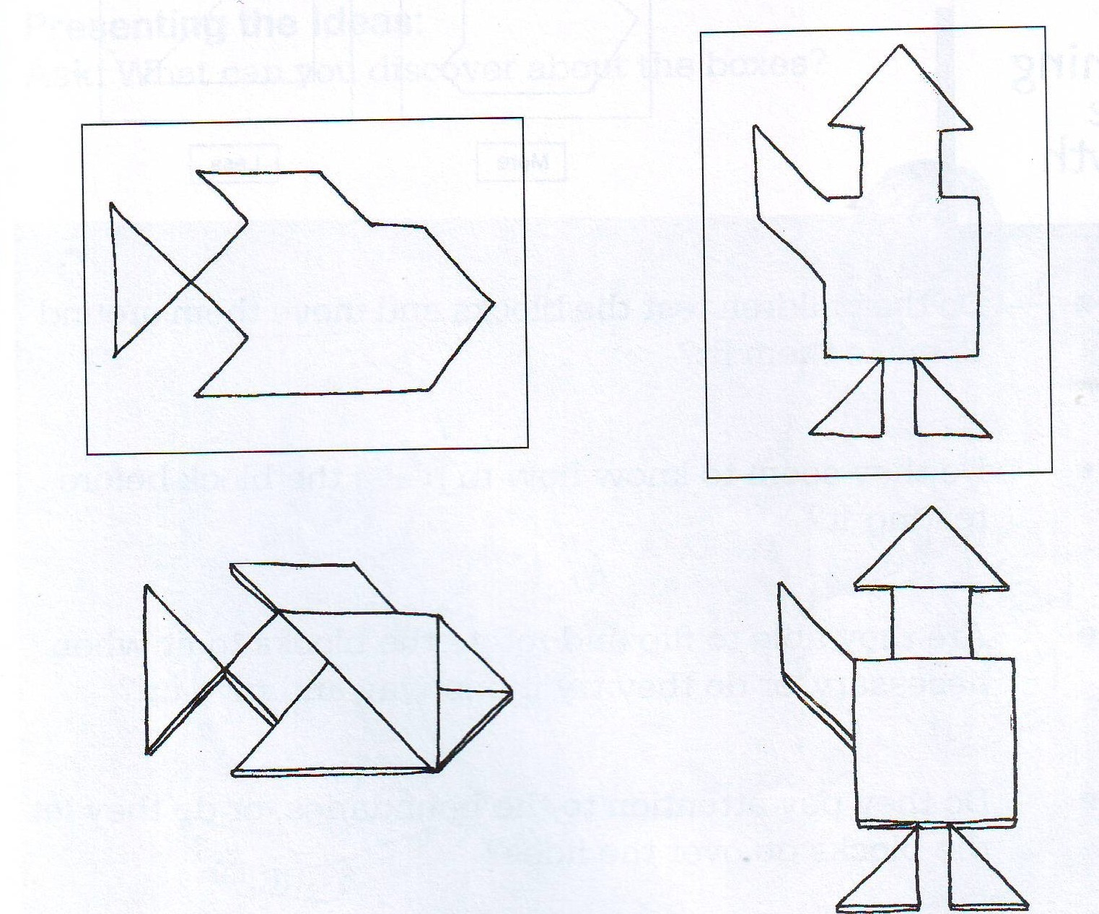

OTHER LANGUAGE ARTS ACTIVITIES

Alpha Toss
Objectives: to recognize letter/word, to form words
Materials: bond paper, bean bags, old/used socks, dried beans, sand
Number of players/participant: 3-4 players or it can also be played by just one child
Procedure:
- Print each letter of the alphabet on a separate A4 sheet.
- In the lower right hand corner, assign a point value to each letter. (use the letter values from Scrabble.)
- Create create bean bags by filling old socks with dried beans, sand, etc., then tying them shut.
- Place letters in four rows, six in the first, seven in the second, six in the third, and seven in the fourth. Students then stand at an assigned line and toss a bean bag onto the playing area. Beginning students must think of a word beginning with the letter upon which the bean bag landed, then use the word in a sentence. Intermediate students should toss two to three bean bags, think of words that began with all letters, then use all words in one sentence. For more advanced students, you might have them toss all six bean bags, then create a word using as many of the letters as possible. Points are assigned for each letter used.

Go Hunting Go!
Objective: increase phonemic awareness; correctly identify initial consonant sounds.
Materials: collection of flashcards or small objects,
No. of Participants: 4 to8
Procedure:
- Have students form a circle. Place flashcards or objects outside the circle.
We're looking for a [word],
We're looking for a [word],
[Sing sound of the letter to the tune of "Heigh, ho, the Derry Oh!"]
We're looking for a [word].
- After each verse, ask a student to find an object or picture beginning with that sound and place it in the center of the circle. Continue until all objects or pictures have been used.
Note: You might also use this song to teach vowel sounds, final consonant sounds, or blends. For added variety, you might give each student a flashcard instead of placing cards or objects outside circle. When a student's sound is sung, he or she steps into the circle.
Jigsaw Sentences
Objective: to arrange words to form simple sentences
Materials: 40 word cards (an assortment of word cards w/ the following categories: nouns, verbs, articles of speech, prepositions – around ten each)
Number of players/participants: 3-4
Procedure:
- Scatter the word cards in the middle of the table.
- Invite the children to form simple sentences using the word cards.
- Variation: set aside a group of word cards that, when arranged properly, form a complete sentence. Invite the children to rearrange the jumbled words in order to form the sentence.

Talk a Drawing
Objective: listen and speak activity; give and follow directions
Materials: blank paper, crayons
Number of players/participants: 4-5
Procedure:
- Give one sheet of paper to each child. Make sure they are not able to see each other’s paper, so you may want to create makeshift partitions between their seats/on the table.
- Explain that you are going to play Talk a Drawing, wherein they are supposed to draw everything you instruct them to.
- When they are ready with their paper and crayons, start telling them what to draw. For example: Draw a blue square in the center of the page.
- Give around 4-5 instructions before ending the round. Each child can compare his drawing with the other members of the group.
- For the second round, invite one of them to be the one to give the instructions for Talk a Drawing. Each child can have a turn giving out the directions.

Where’s the Sound?
Objective: identify initial, medial and final sounds in words
Materials: three paper cups for each child, a bowl of pebbles (to serve as counters), paper and pencil
Number of players/participants: 4-5
Procedure:
- Give each child three paper cups and place it on top of three sheets of paper. Label the paper with “beginning” “middle” and “end”. Place the bowl of pebbles in the middle of the table.
- Explain to the children that they are going to identify which sound belongs in what cup from the words you are going to say. Examples:
- Where’s the p-sound in soap? (end)
- Where’s the p-sound in capital? (middle)
- Where’s the p-sound in pillow? (beginning)
Etc.
- Once they know which sound to listen out for, they will have to locate the position of that sound in the word .
- When they know where the sound is located, they will get one pebble and drop it in the corresponding cup.

Mystery Words
Objective: to rearrange letters to form words
Materials: alphabet letter cards (2 sets)
Number of players/participants: groups of 2 or 3
Procedure:
- Ask the children to form groups of two or three. As soon as they have their groupings, they are ready to play.
- The game entails guessing the mystery word by rearranging the jumbled up letter cards to form the word. Prepare letter cards for them words for the week (example – NATURE, TREE, FISH etc.) – about eight or ten – and give the first set to the two teams.
- At the count of three, each team will work cooperatively to rearrange the letter cards to form the mystery words.
- The team that finishes first and has the most accurate spelling/guesses will win the game.

Make a Match
Objective: to match onset and rimes
Materials: set of onset and rimes
Number of players/participants: 8-10 children
Procedure:
Distribute one card to each student. As you play the music or sing a song ,students will try to form a word by search for a word part that can be combined with the one they are holding to make a match. When all students find their match, provide time for them to share their words with the class, Continue with other word part cards or challenge students to find another match.

Word Sort

Objective: to recognize word features
Materials: word cards
Number of players/participants: groups of 4 - 6
Procedure:
Provide students with a set of words that begin with a specific syllable. Have them sort these words first according to the beginning syllable. Then after the first round have them sort the words using other categories e.g., # of letters, beginning and ending ending sounds.
- Write two things in the story we read that you liked.
- Draw a picture of each.
- Write two things that you disliked.
- Draw a picture of each.
- Share your paper with another student.

Story Sequence Chart
Materials: construction paper, crayons, marker, pencil, paper strips
Number of Players/participants:
Procedure:  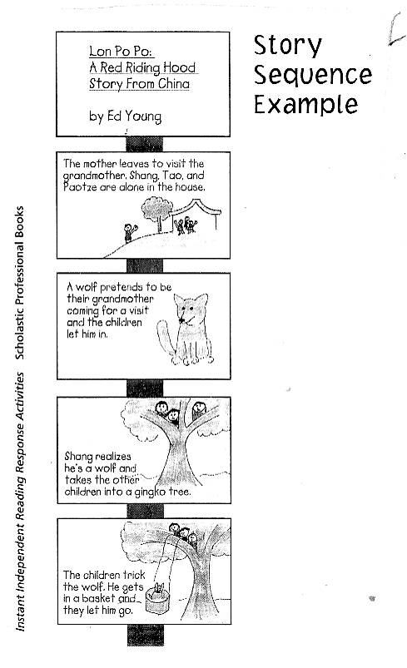 | - Get 5 pieces of 1/2 construction paper  - On the first paper, write the little and author.  - Choose four key events from your book.  - On each of the remaining pieces of paper, draw a picture of one event.  - Write a label for each picture.  - Arrange the cards in the order the events happened. (Put the title card at the top and the first event card directly below it.  - Glue or tape the strips of paper onto the paper strip.  - Use the story sequence cards to help retell the story to another student.

Story Map

Objective: to identify story elements
Materials: story map sheet, crayons, pencil
Number of participants: 8-10
Procedure:  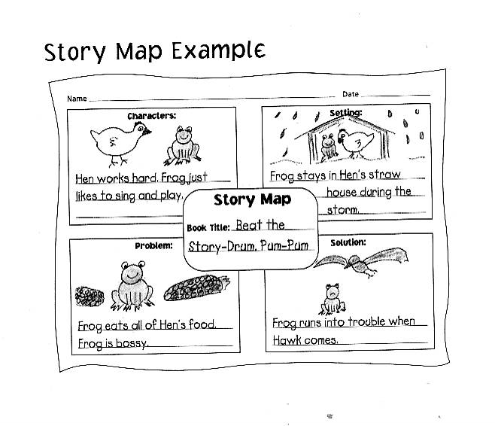 | - In the middle, write the title.  - In the boxes, draw a picture to show each of the following:  - character  - setting  - problem  - solution  - Write a sentence about each.  - Cut out the map

Source: Reading-Writing Workshop

STORIES

The Little Red Hen
Questions Before Reading:
- Everybody has friends right?
- Can you tell me something about your friends?
- Do they help you with things?
Our story today is about....

Questions While Reading:
- What did the little red hen find?
- What did she plan to do with it?
- Do you think her friends will help her do it?

Questions After Reading:
- Whom did we meet in the story?
- Can you tell something about the little red hen’s friends?
- How did the story start?
- What happened at the middle of the story?
- How did it end?

The Little Tree That Longed for Other Leaves
Questions Before Reading:
- If you are asked with one wish, what would it be? Why?
Our story today is about....

Questions While Reading:
- Why was the little tree sad? What did she asked before she slept?
- What do you think will happen?

Questions After Reading:
- What is the problem of the little tree?
- How did he/she solve it?
- If you were the little tree? Will you do the same? Why? Why not?
- How did the story end?

The Fish Who Wished He Could Fly
Questions Before Reading:
- What strange thing would you want to see? Why?
- Will you also ask for strange things?
Our story today is about....

Questions While Reading:
- What does the fish want?
- Do you think, he can get what he ask for?

Questions After Reading:
- Whom did we meet in the story?
- Can you tell something about the fish?
- How did the story start?
- How did it end?

The Tiger In The Cage
Questions Before Reading:
- Tell me something you know about tigers.
- Can you describe them?
- Do you want them as pets?
Our story today is about....

Questions While Reading:
- What did the boy find out while walking?
- What do you think will the tiger do to the boy?

Questions After Reading:
- Whom did we meet in the story?
- Can you tell something about the boy? The tiger? The girl?
- How did the story start?
- What happened in the middle of the story?
- How did it end?
- If you were the boy, what could you have done?

SONGS/POEMS/RHYMES

I'm a Little Seed  (to the tune of "I'm a Little Teapot")  I'm a little seed,  Brown and fat,  I haven't got a front,  And I haven't got a back.  Plant me in the earth,  Give me water each day,  I'll grow to be an apple tree,  While you play!  I dig a hole and plant a seed,  Cover it with dirt, and pull a weed.  Down comes the rain, and out comes the sun,  Up grows my plant,  Oh! What fun! |  | The Gardener Plants the Seeds  (can be sung to the tune of The Farmer in the Dell)  The gardener plants the seeds.  The gardener plants the seeds.  High ho the derry oh,  The gardener plants the seeds.  2nd verse: The rain falls on the ground.  3rd verse: The sun shines bright and warm.  4th verse: The seeds begin to grow.  5th verse: Flowers grow everywhere.

Water Clear, Water Bright  Water clear, water bright,  Is a friend that's worth the having;  Water clear, water bright,  Serves us all from morn 'til night.  Bubbling brooks and streams and rivers,  Springs and lakes and creeks and dams,  Feed the forest and the flowers,  And the grass spread o'er the land.  Water clear, water bright,  Is a friend that's worth the having;  Water clear, water bright,  Serves us all from morn 'til night.  Little raindrops, lightly falling,  Make the old earth new again;  And the dews of early morning  Soothe the summer's burning pain.  Water clear, water bright,  Is a friend that's worth the having;  Water clear, water bright,  Serves us all from morn 'til night.  Tuna, salmon, crab and lobster,  Swim beneath the ocean blue;  Eels and seals and whales and dolphins,  Need our earth's salt water, too.  Water clear, water bright,  Is a friend that's worth the having;  Water clear, water bright,  Serves us all from morn 'til night. |  | What Makes a Garden Grow, Grow, Grow  What makes a garden grow, grow, grow?  (Measure from floor with hand at three levels)  Lots of work with a rake and hoe,  (Pretend to rake and hoe)  Seeds gently planted in a row --  (pretend to plant seeds with thumb and index finger together)  That makes a garden grow, grow, grow.  (Measure from floor with hand at three levels)  What brings the seedlings up from the ground?  (With palms up, close to floor, measure at three levels)  Rain from the sky coming down, down,  (Raise hands high and flutter fingers down, down, down)  Bright yellow sunbeams shining round.  (Make arms into big circle overhead)  Help bring the seedlings up from the ground.  (With palms up, close to floor measure at three levels.)  Five Little Monkeys  Five little monkeys jumping on the bed  One fell off and bumped his head  So Momma called the doctor and the doctor said  No more monkeys jumping on the bed!  Four little monkeys jumping on the bed  One fell off and bumped his head  So Momma called the doctor and the doctor said  No more monkeys jumping on the bed!  Three little monkeys jumping on the bed  One fell off and bumped his head  So Momma called the doctor and the doctor said  No more monkeys jumping on the bed!  Two little monkeys jumping on the bed  One fell off and bumped his head  So Momma called the doctor and the doctor said  No more monkeys jumping on the bed!  One little monkey jumping on the bed  He fell off and bumped his head  So Momma called the doctor and the doctor said  No more monkeys jumping on the bed!  No little monkeys jumping on the bed  None fell off and bumped his head  So Momma called the doctor and the doctor said  Put those monkeys back in bed!

Itsy Bitsy Spider  Itsy bitsy spider went up the water spout  Down came the rain  And washed the spider out  Out came the sun and dried up all the rain  And the itsy bitsy spider went up the spout again  The teeny tiny spider went up the water spout  Down came the rain  And washed the spider out  Out came the sun and dried up all the rain  And the teeny tiny spider went up the spout again  The big humongous spider went up the water spout  Down came the rain  And washed the spider out  Out came the sun and dried up all the rain  And the big humongous spider went up the spout again |  | Instrumental  (do the motions)  (whisper)  Itsy bitsy spider went up the water spout  Down came the rain  And washed the spider out  Out came the sun and dried up all the rain  And the itsy bitsy spider went up the spout again  Itsy bitsy spider went up the water spout  Down came the rain  And washed the spider out  Out came the sun and dried up all the rain  And the itsy bitsy spider went up the spout again

INDOOR/OUTDOOR ACTIVITIES

Ten and Out
Materials : Chalk ,One marker (small chain, coin, or stone) per player
Procedure:
- Use chalk to draw the hopscotch court shown above.
- The first player stands in front of space one. He tosses his marker into that space, then hops on one foot into the space, bends over and picks up his marker, and hops up the court and back again on one foot, hopping in each space both up and back.
- He then tosses his marker into the next space, hops to that space, picks up his marker, and hops up the court and back again.
- He continues hopping in this way until he fouls out (hops on a line, puts both feet down, or misses his target when tossing his marker).
- The players take turns tossing and hopping in the same way.
- When it's the first player's turn again, he starts hopping from where he fouled out on his last turn.
- The winner is the first player to finish the entire sequence of tosses and hops, including the space labeled out.
Names Hopscotch
Materials : Chalk
Directions:
Use chalk to draw any kind of hopscotch court.
- The first player hops up the court and back again on one foot, hopping in each space both up and back.
- If he does this without fouling out (hopping on a line or putting both feet down), he can claim any one space by writing his name on it with chalk.
- If he fouls out, his turn ends.
- The players take turns hopping and claiming spaces in the same way.
- A player must hop over spaces claimed by others, but he may hop with both feet in his own space.
- Play continues when all the spaces have been claimed, but at this point anyone who fouls out is out of the game.
- The game ends when only one player-the winner-remains.
Family Scavenger Hunt

The idea of a scavenger hunt is to find all the items on a list and return them to a designated place as quickly as possible. There are many ways to organize a hunt and many choices to make. You can play as individuals or on teams either inside the house or outside. Here are a few ideas to try:
- All items on the list are easily found in the backyard (they can be hidden before the party). Things like a red leaf, matchstick, old bottle or can, feather, etc.
- Each person or team is given a different list of items to find by asking people around the neighbor hood.
- Alphabet hunt—must find something for each letter of the alphabet.
- Indoor hunt where each person looks for things and checks them off their list when they find them without picking them up.
- Newspaper hunt—each person is given a list of words, sentences, advertisements, or photographs that are to be cut out or circled in a newspaper.
Planting Rice Relay

- Divide the class into two teams and ask them to form two lines.
- Put six empty soda cans/cups along each team’s race track.
- At the signal, the first player runs and deposits one straw or popsicle stick into each of the cans/cups then makes his way back to the starting line.
- He then tags the second person, who proceeds to run the track but this time picking up all the straws or the popsicle sticks before going back to the starting line.
- The third player is tagged, and he does what the first player did. Alternate depositing and picking up all the sticks and straws until the last player makes his way around the course.
- The first team to finish wins the game.

